**“InnoPlateReader”**

**(Implementasi YOLO & OCR Untuk   
Sistem Deteksi Plat Nomor)**

**MANUAL SISTEM DETEKSI PLAT NOMOR**



Penyusun:

ARIESKA RESTU HARPIAN DWIKA

5200411488

**UNIVERSITAS TEKNOLOGI YOGYAKARTA**

**2024**

# Daftar Isi

Daftar Isi i

Daftar Gambar ii

Bagian 1 Pengenalan Antar Muka Sistem 1

1.1 Halaman Home 1

1.1.1 Tampilan Antar Muka Halaman Home 1

1.1.2 Potongan Kode Program Halaman Home 2

1.2 Halaman Train 3

1.2.1 Tampilan Antar Muka Halaman Train 3

1.2.2 Potongan Kode Program Halaman Train 4

1.3 Halaman Hasil Train 6

1.3.1 Tampilan Antar Muka Halaman Hasil Train 7

1.3.2 Potongan Kode Program Halaman Hasil Train 8

1.4 Halaman Predict 9

1.4.1 Tampilan Antar Muka Halaman Predict 9

1.4.2 Potongan Kode Program Halaman Predict 10

1.5 Halaman Hasil Predict 11

1.5.1 Tampilan Antar Muka Halaman Hasil Predict 12

1.5.2 Potongan Kode Program Halaman Hasil Predict 13

Bagian 2 Manual Penggunaan Sistem 16

2.1 Step by step Proses Training 16

2.2 Step by step Proses Predict 19

# Daftar Gambar

Gambar 1.1 Tampilan Halaman Beranda 1

Gambar 1.2 Tampilan Halaman Train 3

Gambar 1.3 Tampilan Halaman Hasil Train 7

Gambar 1.4 Tampilan Halaman Predict 9

Gambar 1.5 Tampilan Halaman Hasil Predict (Bagian 1) 12

Gambar 1.6 Tampilan Halaman Hasil Predict (Bagian 2) 12

Gambar 1.7 Tampilan Halaman Hasil Predict (Bagian 3) 13

# Pengenalan Antar Muka Sistem

## Halaman Home

Halaman beranda adalah halaman yang pertama kali muncul saat pengguna menggunakan sistem. Halaman ini memungkinkan pengguna untuk berpindah halaman 3 menu yang tersedia pada bagian navbar yaitu: Home, Train, dan Predict. Menu “Home” digunakan untuk menampilkan kembali halaman beranda ini. Sedangkan detil untuk kedua menu lainnya akan dijelaskan pada bagian berikutnya. Halaman ini juga memiliki satu tombol “Start Now” pada bagian tengah halaman yang mana merupakan shortcut untuk berpindah ke menu “Predict”.

### Tampilan Antar Muka Halaman Home

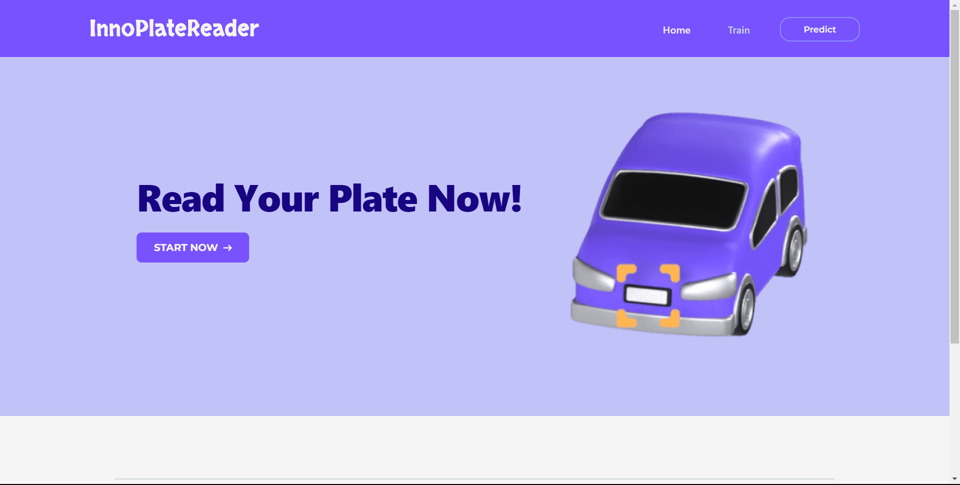

Gambar 1.1 Tampilan Halaman Beranda

### Potongan Kode Program Halaman Home

<!DOCTYPE html>

<html lang="en">

<head>

<meta charset="UTF-8">

<meta http-equiv="X-UA-Compatible" content="IE=edge">

<meta name="viewport" content="width=device-width, initial-scale=1.0">

<title>Home</title>

<link rel="stylesheet" href="{{url_for('static',filename='dist/css/output.css')}}">

</head>

<body class="bg-background">

<!-- Navbar Start -->

<nav class="bg-primary dark:bg-primary pt-3 pb-2 px-4 lg:px-0">

<div class="max-w-screen-xl flex flex-wrap items-center justify-between mx-auto p-4">

<a href="/" class="flex items-center ml-2">

<span class="self-center text-3xl md:text-4xl font-skranji whitespace-nowrap text-text hover:text-white duration-300">InnoPlateReader</span>

</a>

<button data-collapse-toggle="navbar-default" type="button" class="inline-flex items-center p-2 w-10 h-10 justify-center text-sm text-text hover:text-primary rounded-lg md:hidden hover:bg-background focus:outline-none focus:ring-2 focus:ring-gray-400 duration-300" aria-controls="navbar-default" aria-expanded="false">

<span class="sr-only">Open main menu</span>

<svg class="w-5 h-5" aria-hidden="true" xmlns="http://www.w3.org/2000/svg" fill="none" viewBox="0 0 17 14">

<path stroke="currentColor" stroke-linecap="round" stroke-linejoin="round" stroke-width="2" d="M1 1h15M1 7h15M1 13h15"/>

</svg>

</button>

<div class="hidden w-full md:block md:w-auto" id="navbar-default">

<ul class="font-medium flex flex-col p-4 md:p-0 mt-4 border border-gray-100 rounded-lg md:flex-row md:space-x-8 md:mt-0 md:border-0">

<li>

<a href="/" class="block py-2 pl-3 pr-4 font-maitree font-semibold text-text hover:text-white bg-secondary duration-300 rounded md:bg-transparent " aria-current="page">

Home

</a>

</li>

<li>

<a href="/about" class="block py-2 pl-3 pr-4 font-maitree font-semibold text-slate-300 hover:text-white hover:bg-secondary duration-300 rounded md:bg-transparent hover:md:bg-transparent " aria-current="page">

Train

</a>

</li>

<li>

<a href="/read-plate" class="block rounded-2xl font-montserrat font-semibold text-sm px-9 py-2 text-center mr-2 mt-2 md:mt-0 duration-300 text-text hover:text-white hover:bg-secondary border-secondary border-2 focus:ring-4 focus:outline-none">

Predict

</a>

</li>

</ul>

</div>

</div>

</nav>

<!-- Navbar End -->

<!-- Jumbotron Start -->

<section class="bg-secondary bg-opacity-50 pb-10 mb-5">

<div class="py-8 px-4 mx-auto max-w-screen-xl text-center lg:py-16">

<div class="flex flex-col-reverse space-y-4 align-middle md:flex-row md:justify-center md:space-y-0 md:space-x-4">

<div class="self-center flex flex-col mx-2 md:mx-6">

<h1 class="mb-2 lg:mb-4 text-4xl font-extrabold font-simonetta tracking-tight text-center md:text-left self-center text-text2 md:text-5xl lg:text-6xl">

Read Your Plate Now!

</h1>

<a href="/read-plate" class="inline-flex justify-center items-center md:w-fit py-3 px-5 md:px-7 my-3 mx-4 sm:mx-10 md:mx-0 text-base uppercase font-montserrat font-bold text-center text-text hover:text-white rounded-lg bg-primary duration-300 hover:opacity-90 focus:ring-4 focus:ring-blue-200">

Start now

<svg class="w-3.5 h-3.5 ml-2" aria-hidden="true" xmlns="http://www.w3.org/2000/svg" fill="none" viewBox="0 0 14 10">

<path stroke="currentColor" stroke-linecap="round" stroke-linejoin="round" stroke-width="2" d="M1 5h12m0 0L9 1m4 4L9 9"/>

</svg>

</a>

</div>

<img class="h-auto lg:max-w-md max-w-sm self-center justify-items-center" src="../static/assets/car.png" alt="car illustration">

</div>

</div>

</section>

<!-- Jumbotron End -->

<!-- Footer Start -->

<footer class="bg-background mt-5">

<div class="w-full md:w-4/5 px-4 mx-auto py-4 sm:pt-6 md:pt-8 lg:pt-12 sm:pb-2">

<div class="mx-auto max-w-screen-xl px-4 pt-8 pb-2">

<hr class="border border-gray-300 sm:mx-auto" />

</div>

<div class="mx-auto max-w-screen-xl p-4 py-6 lg:py-8">

<div class="flex flex-col md:flex-row md:justify-between">

<div class="w-fit mb-7 sm:mb-10 md:mb-0 self-center md:self-auto md:ml-4 lg:ml-6">

<a href="/" class="flex items-center mb-2 md:mb-3 p-3">

<span class="self-center text-4xl lg:text-5xl font-skranji whitespace-nowrap text-accent">InnoPlateReader</span>

</a>

<div class="flex flex-row justify-evenly md:justify-start md:space-x-3 md:pl-4 mx-2 md:mx-0">

<!-- Instagram -->

<a href="instagram.com/acilrestu12/" class="w-[35px] md:w-[38px] fill-gray-500 hover:fill-accent duration-300">

<svg xmlns="http://www.w3.org/2000/svg" viewBox="0 0 30 30">

<path d="M 15 2 C 7.832 2 2 7.832 2 15 C 2 22.168 7.832 28 15 28 C 22.168 28 28 22.168 28 15 C 28 7.832 22.168 2 15 2 z M 11.666016 6 L 18.332031 6 C 21.457031 6 24 8.5420156 24 11.666016 L 24 18.332031 C 24 21.457031 21.457984 24 18.333984 24 L 11.667969 24 C 8.5429688 24 6 21.457984 6 18.333984 L 6 11.667969 C 6 8.5429688 8.5420156 6 11.666016 6 z M 11.666016 8 C 9.6450156 8 8 9.6459688 8 11.667969 L 8 18.333984 C 8 20.354984 9.6459688 22 11.667969 22 L 18.333984 22 C 20.354984 22 22 20.354031 22 18.332031 L 22 11.666016 C 22 9.6450156 20.354031 8 18.332031 8 L 11.666016 8 z M 19.667969 9.6660156 C 20.035969 9.6660156 20.333984 9.9640312 20.333984 10.332031 C 20.333984 10.700031 20.035969 11 19.667969 11 C 19.299969 11 19 10.700031 19 10.332031 C 19 9.9640312 19.299969 9.6660156 19.667969 9.6660156 z M 15 10 C 17.757 10 20 12.243 20 15 C 20 17.757 17.757 20 15 20 C 12.243 20 10 17.757 10 15 C 10 12.243 12.243 10 15 10 z M 15 12 A 3 3 0 0 0 15 18 A 3 3 0 0 0 15 12 z"/>

</svg>

</a>

<!-- Facebook -->

<a href="facebook.com/AcilRestu12/" class="w-[35px] md:w-[38px] fill-gray-500 hover:fill-accent duration-300">

<?xml version="1.0"?>

<svg xmlns="http://www.w3.org/2000/svg" viewBox="0 0 30 30">

<path d="M15,3C8.373,3,3,8.373,3,15c0,6.016,4.432,10.984,10.206,11.852V18.18h-2.969v-3.154h2.969v-2.099c0-3.475,1.693-5,4.581-5 c1.383,0,2.115,0.103,2.461,0.149v2.753h-1.97c-1.226,0-1.654,1.163-1.654,2.473v1.724h3.593L19.73,18.18h-3.106v8.697 C22.481,26.083,27,21.075,27,15C27,8.373,21.627,3,15,3z"/>

</svg>

</a>

<!-- Tiktok -->

<a href="" class="w-[35px] md:w-[38px] fill-gray-500 hover:fill-accent duration-300">

<?xml version="1.0"?>

<svg xmlns="http://www.w3.org/2000/svg" viewBox="0 0 30 30">

<path d="M24,4H6C4.895,4,4,4.895,4,6v18c0,1.105,0.895,2,2,2h18c1.105,0,2-0.895,2-2V6C26,4.895,25.104,4,24,4z M22.689,13.474 c-0.13,0.012-0.261,0.02-0.393,0.02c-1.495,0-2.809-0.768-3.574-1.931c0,3.049,0,6.519,0,6.577c0,2.685-2.177,4.861-4.861,4.861 C11.177,23,9,20.823,9,18.139c0-2.685,2.177-4.861,4.861-4.861c0.102,0,0.201,0.009,0.3,0.015v2.396c-0.1-0.012-0.197-0.03-0.3-0.03 c-1.37,0-2.481,1.111-2.481,2.481s1.11,2.481,2.481,2.481c1.371,0,2.581-1.08,2.581-2.45c0-0.055,0.024-11.17,0.024-11.17h2.289 c0.215,2.047,1.868,3.663,3.934,3.811V13.474z"/>

</svg>

</a>

<!-- Twitter -->

<a href="" class="w-[35px] md:w-[38px] fill-gray-500 hover:fill-accent duration-300">

<?xml version="1.0"?>

<svg xmlns="http://www.w3.org/2000/svg" viewBox="0 0 50 50">

<path d="M 11 4 C 7.134 4 4 7.134 4 11 L 4 39 C 4 42.866 7.134 46 11 46 L 39 46 C 42.866 46 46 42.866 46 39 L 46 11 C 46 7.134 42.866 4 39 4 L 11 4 z M 13.085938 13 L 21.023438 13 L 26.660156 21.009766 L 33.5 13 L 36 13 L 27.789062 22.613281 L 37.914062 37 L 29.978516 37 L 23.4375 27.707031 L 15.5 37 L 13 37 L 22.308594 26.103516 L 13.085938 13 z M 16.914062 15 L 31.021484 35 L 34.085938 35 L 19.978516 15 L 16.914062 15 z"/>

</svg>

</a>

</div>

</div>

<!-- <div class="grid grid-cols-1 gap-8 sm:gap-4 md:gap-2 lg:gap-10 sm:grid-cols-2 md:grid-cols-3 mt-3 sm:mt-0 mx-3 sm:mx-5 md:mr-4 lg:mr-6"> -->

<!-- Contact Us -->

<div class="mt-3 pt-5 sm:mt-0 mx-3 sm:mx-5 md:mr-4 lg:mr-8">

<h2 class="mb-4 text-base lg:text-lg font-bold font-montserrat text-gray-500 uppercase">contact us</h2>

<ul class="text-gray-400 font-medium font-montserrat text-base lg:text-lg">

<li class="mb-2 md:mb-3 flex flex-row align-middle">

<svg width="30" height="30" viewBox="0 0 32 32" fill="none" xmlns="http://www.w3.org/2000/svg">

<path fill-rule="evenodd" clip-rule="evenodd" d="M3.73838 11.1377C3.36486 14.6082 3.38151 18.6109 3.90127 22.0673C4.18887 23.9798 5.74976 25.446 7.67652 25.6135L9.69016 25.7885C13.8889 26.1535 18.1114 26.1535 22.3101 25.7885L24.3237 25.6135C26.2505 25.446 27.8114 23.9798 28.099 22.0673C28.6188 18.6108 28.6354 14.6084 28.2619 11.1379C28.2136 10.7355 28.1593 10.3337 28.099 9.93261C27.8114 8.02009 26.2505 6.55389 24.3237 6.3864L22.3101 6.21136C18.1114 5.84638 13.8889 5.84638 9.69016 6.21136L7.67652 6.38641C5.74976 6.55389 4.18887 8.02009 3.90127 9.93261C3.84096 10.3337 3.78666 10.7354 3.73838 11.1377ZM9.86337 8.20385C13.9468 7.84888 18.0534 7.84888 22.1369 8.20385L24.1505 8.37889C25.1563 8.46632 25.9711 9.23168 26.1212 10.23C26.1368 10.3337 26.152 10.4374 26.1667 10.5412L18.7521 14.6604C17.0406 15.6113 14.9596 15.6113 13.2481 14.6604L5.83352 10.5412C5.84827 10.4374 5.86344 10.3337 5.87903 10.23C6.02916 9.23168 6.84395 8.46632 7.84972 8.37889L9.86337 8.20385ZM26.4115 12.6931C26.6701 15.7168 26.5734 18.7633 26.1212 21.7699C25.9711 22.7682 25.1563 23.5336 24.1505 23.621L22.1369 23.7961C18.0534 24.151 13.9468 24.151 9.86337 23.7961L7.84972 23.621C6.84395 23.5336 6.02916 22.7682 5.87903 21.7699C5.42692 18.7633 5.33017 15.7168 5.58879 12.6932L12.2768 16.4088C14.5923 17.6952 17.4078 17.6952 19.7234 16.4088L26.4115 12.6931Z" fill="#707070"/>

</svg>

<a href="/" class="hover:underline ml-1 duration-300">arieskarestu02@gmail.com</a>

</li>

<li class="mb-2 md:mb-4 flex flex-row align-middle">

<svg width="30" height="30" viewBox="0 0 32 32" fill="none" xmlns="http://www.w3.org/2000/svg">

<path fill-rule="evenodd" clip-rule="evenodd" d="M7.78705 13.1419C10.1701 18.3311 14.4108 22.4566 19.6825 24.6921L19.6991 24.6991L20.7175 25.1531C22.0144 25.7309 23.5387 25.3205 24.3701 24.1697L26.0693 21.8181C26.1731 21.6744 26.1463 21.4747 26.0084 21.3634L23.0421 18.9704C22.8946 18.8514 22.6778 18.8791 22.565 19.0313L21.4105 20.5892C21.1301 20.9675 20.6238 21.099 20.1948 20.9048C16.2529 19.1209 13.0853 15.9533 11.3014 12.0114C11.1072 11.5824 11.2387 11.0761 11.617 10.7957L13.1749 9.64122C13.3271 9.52841 13.3548 9.31157 13.2358 9.16411L10.8424 6.19739C10.7312 6.0595 10.5315 6.03272 10.3879 6.13641L8.02352 7.84329C6.86513 8.67954 6.45719 10.2167 7.04847 11.5173L7.78626 13.1402C7.78652 13.1407 7.78679 13.1413 7.78705 13.1419ZM18.8933 26.5298C13.1652 24.0984 8.55808 19.6143 5.96868 13.9747L5.96712 13.9713L5.22779 12.345C4.24232 10.1773 4.92223 7.61545 6.85287 6.22169L9.21726 4.51482C10.2228 3.78894 11.6204 3.97641 12.3991 4.9416L14.7924 7.90833C15.6252 8.94056 15.4312 10.4584 14.3657 11.2481L13.473 11.9096C14.9809 14.8355 17.3707 17.2253 20.2966 18.7332L20.9581 17.8405C21.7478 16.775 23.2657 16.581 24.2979 17.4138L27.2642 19.8068C28.2297 20.5857 28.4169 21.9839 27.6904 22.9894L25.9913 25.341C24.6055 27.259 22.065 27.9429 19.9036 26.98L18.8933 26.5298Z" fill="#707070"/>

</svg>

<a href="/" class="hover:underline ml-1 duration-300">089636445795</a>

</li>

</ul>

</div>

<!-- </div> -->

</div>

<!-- <hr class="my-6 border border-gray-300 sm:mx-auto lg:my-8" /> -->

<div class="text-center my-6 sm:mt-8 md:mt-10 lg:mt-14 sm:mb-0">

<span class="text-xs lg:text-sm text-gray-400 sm:text-center">

© 2023-2024

<a href="/" class="hover:underline">

InnoPlateReader

</a>. All Rights Reserved.

</span>

</div>

</div>

</div>

</footer>

<!-- Footer End -->

<script src="https://cdnjs.cloudflare.com/ajax/libs/flowbite/2.2.0/flowbite.min.js"></script>

</body>

</html>

## Halaman Train

Halaman pelatihan dapat diakses oleh pengguna dengan memilih menu “Train” pada navbar halaman Home. Halaman ini digunakan untuk menjalankan tahap pelatihan pada YOLO yang akan digunakan untuk melakukan pengenalan objek dan nantinya akan dibantu oleh EASYOCR untuk melakukan pembacaan karakter plat. Pengguna harus melakukan upload file data citra kendaraan dan data label dari plat nomernya. Selain itu, ada beberapa hyperparameter yang perlu diisikan oleh pengguna antara lain: epoch dan confidence. Nilai pada epoch menunjukkan maksimum epoch yang akan dijalankan selama tahap pelatihan. Nilai confidence menunjukkan nilai probabilitas bounding box yang mendeteksi sebuah objek.

### Tampilan Antar Muka Halaman Train

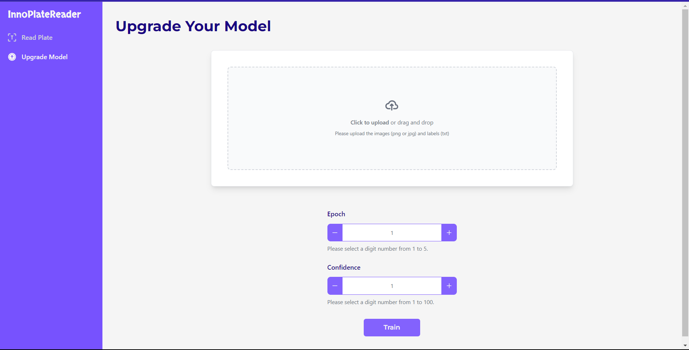

Gambar 1.2 Tampilan Halaman Train

### Potongan Kode Program Halaman Train

<!-- Main Start -->

<section class="p-4 sm:ml-64">

<div class="p-4">

<h2 id="sub-header" class="text-3xl md:text-4xl font-montserrat font-bold text-accent mt-2 ">Upgrade Your Model</h2>

<!-- File Upload -->

<div class="max-w-sm md:max-w-xl lg:max-w-4xl min-h-fit p-8 bg-white border border-gray-200 rounded-lg shadow-lg md:p-10 mx-auto mt-10">

<div class="flex flex-col items-center justify-center w-full">

<label id="label-dropzone" for="dropzone-file" class="relative flex flex-col items-center justify-center w-full h-64 border-2 border-gray-300 border-dashed rounded-lg cursor-pointer bg-gray-50 hover:bg-gray-100">

<div id="tampilan-input-awal" class="opacity-100 flex flex-col items-center justify-center pt-5 pb-6">

<svg class="w-8 h-8 mb-4 text-gray-500 dark:text-gray-400" aria-hidden="true" xmlns="http://www.w3.org/2000/svg" fill="none" viewBox="0 0 20 16">

<path stroke="currentColor" stroke-linecap="round" stroke-linejoin="round" stroke-width="2" d="M13 13h3a3 3 0 0 0 0-6h-.025A5.56 5.56 0 0 0 16 6.5 5.5 5.5 0 0 0 5.207 5.021C5.137 5.017 5.071 5 5 5a4 4 0 0 0 0 8h2.167M10 15V6m0 0L8 8m2-2 2 2"/>

</svg>

<p class="mb-2 text-sm text-gray-500 dark:text-gray-400"><span class="font-semibold">Click to upload</span> or drag and drop</p>

<p class="text-xs text-gray-500 dark:text-gray-400">Please upload the images (png or jpg) and labels (txt)</p>

</div>

<!-- <input id="dropzone-file" type="file" name="input-image" class="absolute top-0 left-0 w-full h-full opacity-0 cursor-pointer" /> -->

<div id="tampilan-input-akhir" class="opacity-0 absolute top-0 left-0 flex items-center justify-center w-full h-full font-medium text-sm text-gray-400">

{{ dropzone.create(action='upload_train') }}

{{ dropzone.load_js() }}

{{ dropzone.style('width: 100%; height: 100%; text-align:center; vertical-align: middle; border: none; overflow-y: scroll') }}

</div>

</label>

</div>

</div>

<!-- Hyperparameter -->

<div class="max-w-sm min-h-fit py-4 px-8 mx-auto mt-10">

<form action="/train-model" method="POST">

<label for="epoch" class="block mb-3 text-base font-medium text-accent">Epoch</label>

<div class="relative flex items-center">

<button type="button" id="decrement-button" data-input-counter-decrement="epoch" class="bg-primary opacity-90 hover:opacity-100 border border-primary rounded-s-lg p-3 h-11 focus:ring-primary focus:ring-2 focus:outline-none">

<svg class="w-3 h-3 text-text hover:text-white" aria-hidden="true" xmlns="http://www.w3.org/2000/svg" fill="none" viewBox="0 0 18 2">

<path stroke="currentColor" stroke-linecap="round" stroke-linejoin="round" stroke-width="2" d="M1 1h16"/>

</svg>

</button>

<input type="text" id="epoch" name="epoch" data-input-counter data-input-counter-min="1" data-input-counter-max="5" aria-describedby="helper-text-explanation" class="bg-white border-x-0 border-primary h-11 text-center text-primary text-sm focus:ring-primary focus:border-primaring-primary block w-full py-2.5" placeholder="1" required>

<button type="button" id="increment-button" data-input-counter-increment="epoch" class="bg-primary opacity-90 hover:opacity-100 border border-primary rounded-e-lg p-3 h-11 focus:ring-primary focus:ring-2 focus:outline-none">

<svg class="w-3 h-3 text-text hover:text-white" aria-hidden="true" xmlns="http://www.w3.org/2000/svg" fill="none" viewBox="0 0 18 18">

<path stroke="currentColor" stroke-linecap="round" stroke-linejoin="round" stroke-width="2" d="M9 1v16M1 9h16"/>

</svg>

</button>

</div>

<p id="helper-text-explanation" class="mt-2 mb-4 md:mb-6 text-sm text-gray-500">Please select a digit number from 1 to 5.</p>

<label for="confidence" class="block mb-3 text-base font-medium text-accent">Confidence</label>

<div class="relative flex items-center">

<button type="button" id="decrement-button" data-input-counter-decrement="confidence" class="bg-primary opacity-90 hover:opacity-100 border border-primary rounded-s-lg p-3 h-11 focus:ring-primary focus:ring-2 focus:outline-none">

<svg class="w-3 h-3 text-text hover:text-white" aria-hidden="true" xmlns="http://www.w3.org/2000/svg" fill="none" viewBox="0 0 18 2">

<path stroke="currentColor" stroke-linecap="round" stroke-linejoin="round" stroke-width="2" d="M1 1h16"/>

</svg>

</button>

<input type="text" id="confidence" name="confidence" data-input-counter data-input-counter-min="1" data-input-counter-max="100" aria-describedby="helper-text-explanation" class="bg-white border-x-0 border-primary h-11 text-center text-primary text-sm focus:ring-primary focus:border-primaring-primary block w-full py-2.5" placeholder="1" required>

<button type="button" id="increment-button" data-input-counter-increment="confidence" class="bg-primary opacity-90 hover:opacity-100 border border-primary rounded-e-lg p-3 h-11 focus:ring-primary focus:ring-2 focus:outline-none">

<svg class="w-3 h-3 text-text hover:text-white" aria-hidden="true" xmlns="http://www.w3.org/2000/svg" fill="none" viewBox="0 0 18 18">

<path stroke="currentColor" stroke-linecap="round" stroke-linejoin="round" stroke-width="2" d="M9 1v16M1 9h16"/>

</svg>

</button>

</div>

<p id="helper-text-explanation" class="mt-2 mb-4 md:mb-6 text-sm text-gray-500">Please select a digit number from 1 to 100.</p>

<input id="start-train" type="hidden" name="start-train" value="False">

<div class="mt-6 md:mt-8 text-center">

<button type="submit" class="text-base text-center font-semibold rounded-md font-montserrat px-12 py-2 duration-300 text-text hover:text-white bg-primary opacity-90 hover:opacity-100 border-primary border-2 focus:ring-4 focus:outline-none focus:ring-primary">

Train

</button>

</div>

</form>

</div>

</div>

</section>

<!-- Main End -->

<script src="https://cdnjs.cloudflare.com/ajax/libs/flowbite/2.2.0/flowbite.min.js"></script>

<script>

Dropzone.options.myDropzone = {

init: function() {

'upload-train' // upload queue when button click

},

}

</script>

<script>

Dropzone.options.myDropzone = {

init: function () {

this.on("addedfile", function (file) {

// File berhasil diupload, tampilkan elemen dengan id "tampilan-awal"

document.querySelector('#tampilan-input-awal').classList.replace('flex', 'hidden')

document.querySelector('#tampilan-input-akhir').classList.replace('opacity-0', 'opacity-100')

document.querySelector('#tampilan-input-akhir').classList.remove('absolute', 'top-0', 'left-0')

document.querySelector('#label-dropzone').classList.replace('h-64', 'h-96')

document.querySelector('#sub-header').innerHTML = 'Dataset Preview'

document.querySelector('#start-train').setAttribute('value', 'True')

});

}

};

</script>

{% block content %}

<main class="main-content">

<div class="container pt-8">

<div class="card">

<div class="card-header pb-0">

<h6>Tabel Master Data</h6>

</div>

<div class="card-body">

<div class="table-responsive pt-0">

<table class="table align-items-center mb-0" id="cars-table">

<thead>

<tr class="text-start">

<th class="text-uppercase text-sm font-weight-bolder">File Name</th>

<th class="text-uppercase text-sm font-weight-bolder">Image</th>

<th class="text-uppercase text-sm font-weight-bolder">Brand</th>

<th class="text-uppercase text-sm font-weight-bolder">Model</th>

</tr>

</thead>

<tbody>

{% for car in cars_data %}

<tr>

<td scope="row">{{ car[2] }}</td>

<td>

<img src="{{ car[1] }}" alt="{{ car[2] }}" class="img-fluid rounded" width="240">

</td>

<td>{{ car[3] }}</td>

<td>{{ car[4] }}</td>

</tr>

{% endfor %}

</tbody>

</table>

</div>

</div>

</div>

</div>

</main>

{% endblock %}

{% block contentScript %}

<script src="{{ url_for('static', filename='js/plugins/jquery.min.js') }}" type="text/javascript"></script>

<script src="{{ url_for('static', filename='js/plugins/jquery.dataTables.min.js') }}" type="text/javascript"></script>

<script src="{{ url_for('static', filename='js/plugins/dataTables.bootstrap5.min.js') }}"

type="text/javascript"></script>

<!-- <script type="text/javascript">

const dataTableBasic = new simpleDatatables.DataTable("#cars-table", {

searchable: true,

fixedHeight: true

});

</script> -->

<script>

document.addEventListener('DOMContentLoaded', function () {

$(document).ready(function () {

$('#cars-table').DataTable();

});

});

</script>

{% endblock contentScript %}

## Halaman Hasil Train

Halaman hasil pelatihan adalah halaman yang akan muncul setelah pengguna melakukan training pada halaman Train. Halaman ini berisi gambar confusion matrix dari hasil training model YOLO. Pada halaman ini juga terdapat tombol “Predict” dan tombol “Save Model”. Tombol “Predict” akan mengarah ke halaman Predict. Sedangkan tombol “Save Model” berfungsi untuk menyimpan model yang telah dilatih sebelumnya. Gambar 1.3 berikut merupakan tampilan dari halaman hasil train.

### Tampilan Antar Muka Halaman Hasil Train

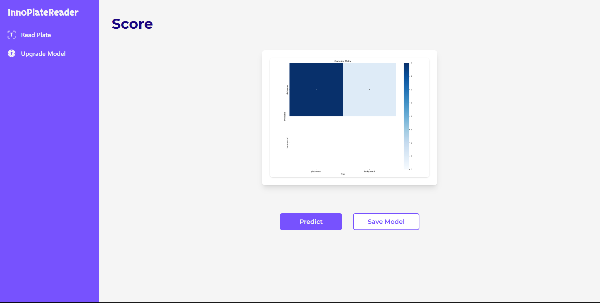

Gambar 1.3 Tampilan Halaman Hasil Train

### Potongan Kode Program Halaman Hasil Train

<!-- Main Start -->

<section class="p-4 sm:ml-64">

<div class="p-4 ">

<!-- Header -->

<h2 class="text-3xl md:text-4xl font-montserrat font-bold text-accent mt-2 ">Score</h2>

<!-- Images -->

<div class="w-full mx-auto py-4 flex flex-col justify-between">

<!-- Score Image -->

<div class="mx-auto my-4 md:my-6 lg:my-8">

<div class="max-w-md p-4 lg:p-5 mx-auto bg-white rounded-lg shadow-lg">

<!-- <img class="transition-all duration-300 rounded-lg" src="{{ plotTrain }}" alt="Plot Train"> -->

<img class="transition-all duration-300 rounded-lg shadow hover:shadow-lg md:hover:shadow-xl hover:shadow-gray-300 ease-in-out md:hover:scale-125 lg:hover:scale-150" src="{{ plotTrain }}" alt="Plot Train">

</div>

</div>

</div>

<!-- Result Train -->

<div class="max-w-sm mx-auto">

<div class="w-full mx-auto flex flex-col md:flex-row mt-2 md:mt-0 justify-center md:justify-around">

<a href="/read-plate" class="w-fit mx-auto text-base text-center font-semibold rounded-md font-montserrat px-12 py-2 mt-4 md:mt-6 duration-300 text-text hover:text-white bg-primary border-primary border-2 focus:ring-4 focus:outline-none focus:ring-primary">

Predict

</a>

<a href="/save-model" class="w-fit mx-auto text-base text-center font-semibold rounded-md font-montserrat px-9 py-2 mt-4 md:mt-6 duration-300 text-primary hover:text-white bg-white hover:bg-primary border-primary border-2 focus:ring-4 focus:outline-none focus:ring-primary">

Save Model

</a>

</div>

</div>

</div>

</section>

<!-- Main End -->

## Halaman Predict

Halaman predict adalah halaman yang digunakan untuk menguji model yang telah dilatih sebelumnya. Pengguna dapat mengakses halaman ini melalui du acara yaitu menggunakan menu Predict yang ada pada bagian atas pada halaman home atau melalu tombol “Start Now” yang ada pada halaman beranda. Pada halaman ini, pengguna harus melakukan upload citra kendaraan yang akan diujikan. Setelah itu, untuk memulai pengujiannya, pengguna harus menekan tombol “Process”. Setelah prosesnya selesai, maka sistem akan menampilkan halaman hasil predict.

### Tampilan Antar Muka Halaman Predict

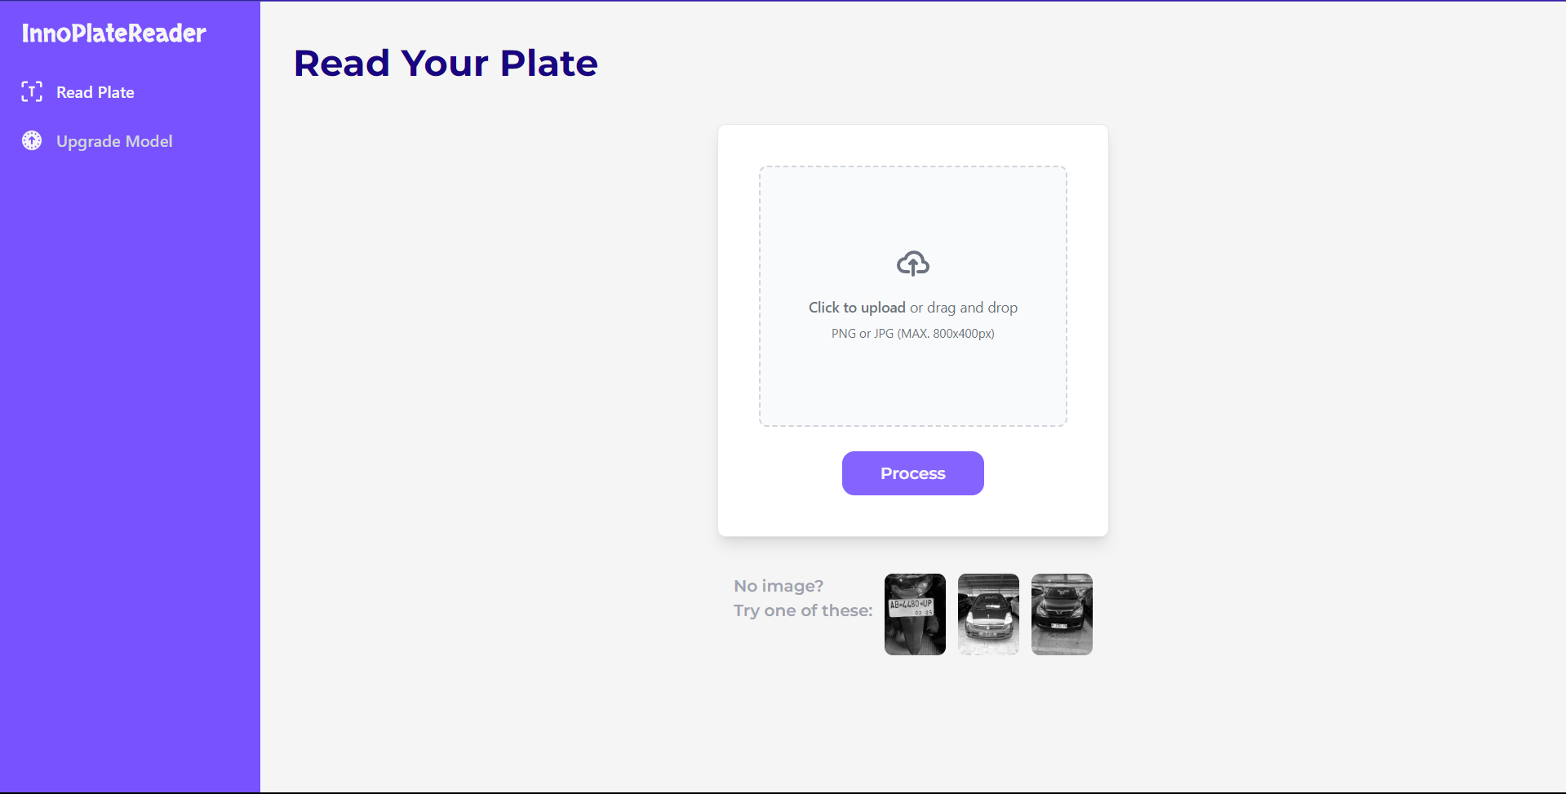

Gambar 1.4 Tampilan Halaman Predict

### Potongan Kode Program Halaman Predict

<!-- Main Start -->

<section class="p-4 sm:ml-64">

<div class="p-4">

<h2 class="text-3xl md:text-4xl font-montserrat font-bold text-accent mt-2 ">Read Your Plate </h2>

<!-- File Upload -->

<div class="w-full max-w-sm min-h-fit p-8 bg-white border border-gray-200 rounded-lg shadow-lg md:p-10 mx-auto mt-10">

<div class="flex flex-col items-center justify-center w-full">

<label for="dropzone-file" class="relative flex flex-col items-center justify-center w-full h-64 border-2 border-gray-300 border-dashed rounded-lg cursor-pointer bg-gray-50 hover:bg-gray-100">

<div id="tampilan-input-awal" class="opacity-100 flex flex-col items-center justify-center pt-5 pb-6">

<svg class="w-8 h-8 mb-4 text-gray-500 dark:text-gray-400" aria-hidden="true" xmlns="http://www.w3.org/2000/svg" fill="none" viewBox="0 0 20 16">

<path stroke="currentColor" stroke-linecap="round" stroke-linejoin="round" stroke-width="2" d="M13 13h3a3 3 0 0 0 0-6h-.025A5.56 5.56 0 0 0 16 6.5 5.5 5.5 0 0 0 5.207 5.021C5.137 5.017 5.071 5 5 5a4 4 0 0 0 0 8h2.167M10 15V6m0 0L8 8m2-2 2 2"/>

</svg>

<p class="mb-2 text-sm text-gray-500 dark:text-gray-400"><span class="font-semibold">Click to upload</span> or drag and drop</p>

<p class="text-xs text-gray-500 dark:text-gray-400">PNG or JPG (MAX. 800x400px)</p>

</div>

<!-- <input id="dropzone-file" type="file" name="input-image" class="absolute top-0 left-0 w-full h-full opacity-0 cursor-pointer" /> -->

<div id="tampilan-input-akhir" class="opacity-0 absolute top-0 left-0 flex items-center justify-center w-full h-full font-medium text-sm text-gray-400">

{{ dropzone.create(action='upload') }}

{{ dropzone.load_js() }}

{{ dropzone.style('width: 100%; height: 100%; text-align:center; vertical-align: middle; border: none;') }}

</div>

</label>

<form action="/result" method="POST">

<input type="hidden" name="start-process-read" value="True">

<button type="submit" class="text-base text-center font-semibold rounded-xl font-montserrat px-9 py-2 mt-4 md:mt-6 duration-300 text-text hover:text-white bg-primary opacity-90 hover:opacity-100 border-primary border-2 focus:ring-4 focus:outline-none focus:ring-primary">

Process

</button>

</form>

</div>

</div>

<!-- Another Images -->

<div class="flex flex-row justify-between mt-5 mx-auto p-4 w-full max-w-sm">

<p class="flex flex-col font-montserrat font-semibold text-sm md:text-base text-gray-400">

<span>No image?</span>

<span>Try one of these:</span>

</p>

<div class="flex flex-row space-x-3">

<a href="/example-1" class="w-[60px] h-[100px]">

<img class="transition-all duration-300 rounded-lg cursor-pointer filter grayscale hover:grayscale-0" src="{{ url_for('static',filename='images/example/K2_AB4480UP.jpg') }}" alt="Example 1">

</a>

<a href="/example-2" class="w-[60px] h-[100px]">

<img class="transition-all duration-300 rounded-lg cursor-pointer filter grayscale hover:grayscale-0" src="{{ url_for('static',filename='images/example/K3_AB1510BA.jpg') }}" alt="Example 2">

</a>

## Halaman Hasil Predict

Halaman hasil predict adalah halaman yang menampilkan hasil dari proses-proses selama melakukan pengujian. Dimana pada halaman ini akan menampilkan citra asil, citra hasil deteksi objek, citra hasil crop objek, dan citra hasil teks deteksi, serta hasil teks plat nomer. Pada halaman ini juga terdapat tombol “Download” dan “Read Again”. Tombol “Download” berfungsi untuk melakukan download dari hasil deteksi. Sedangkan tombol “Read Again” berfungsi untuk kembali ke halaman predict.

### Tampilan Antar Muka Halaman Hasil Predict

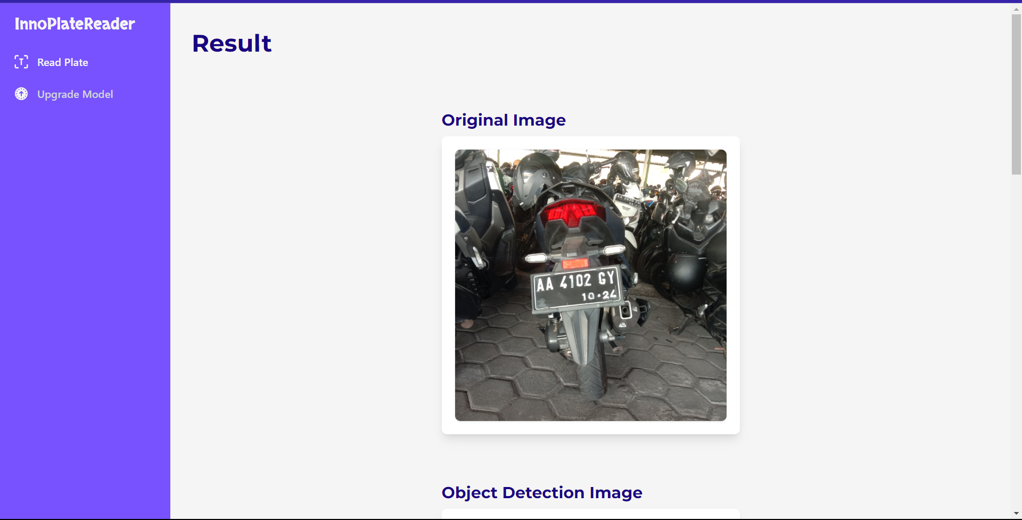

Gambar 1.5 Tampilan Halaman Hasil Predict (Bagian 1)

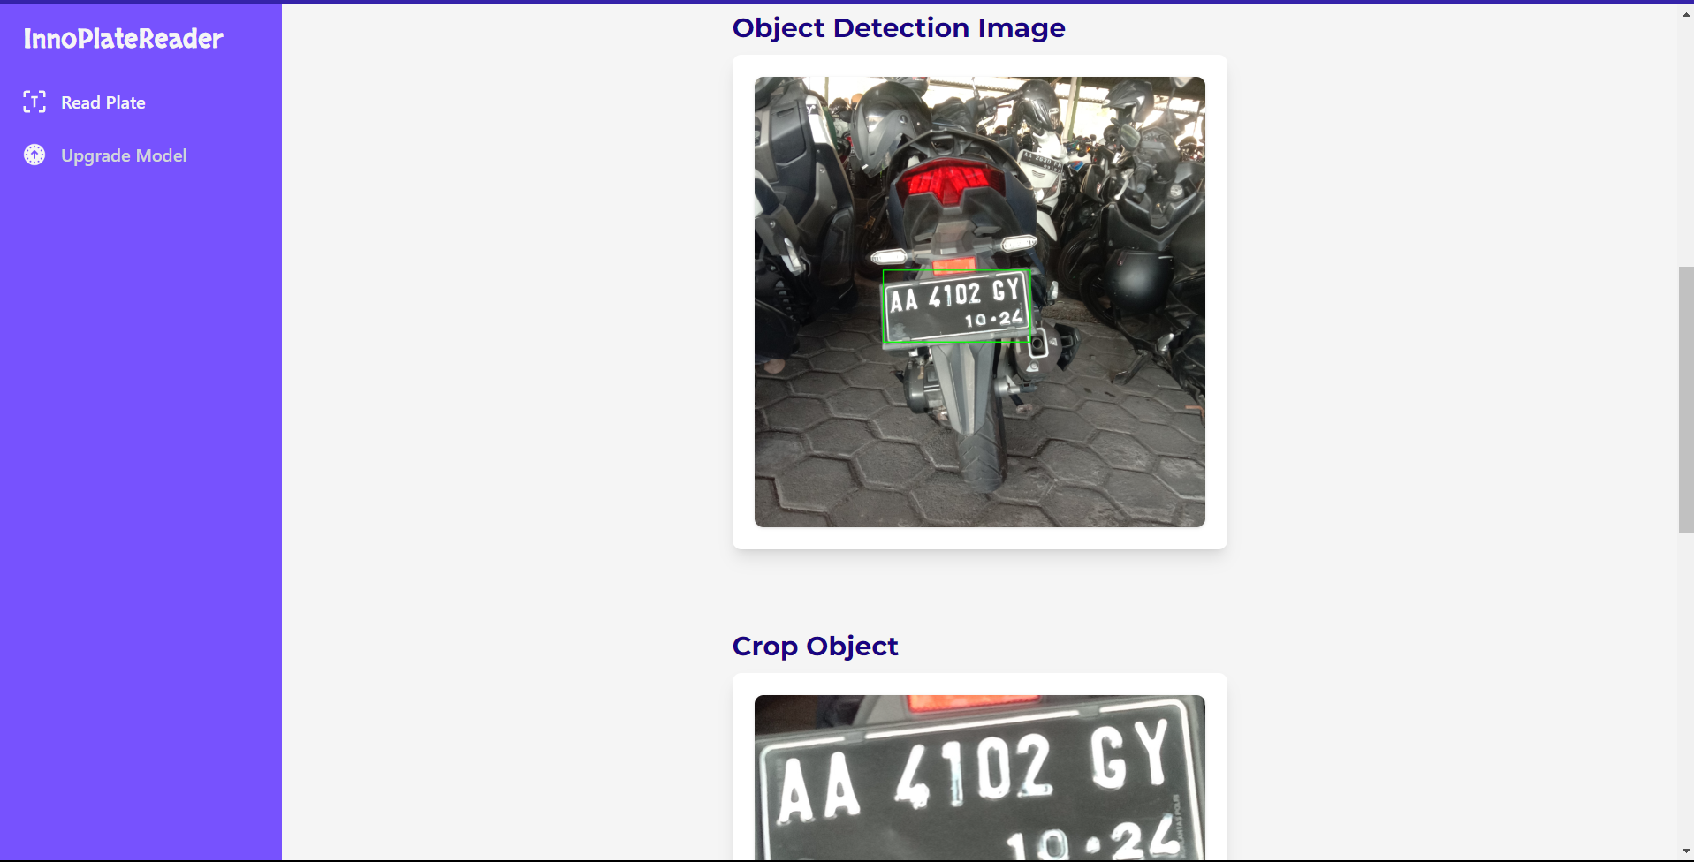

Gambar 1.6 Tampilan Halaman Hasil Predict (Bagian 2)

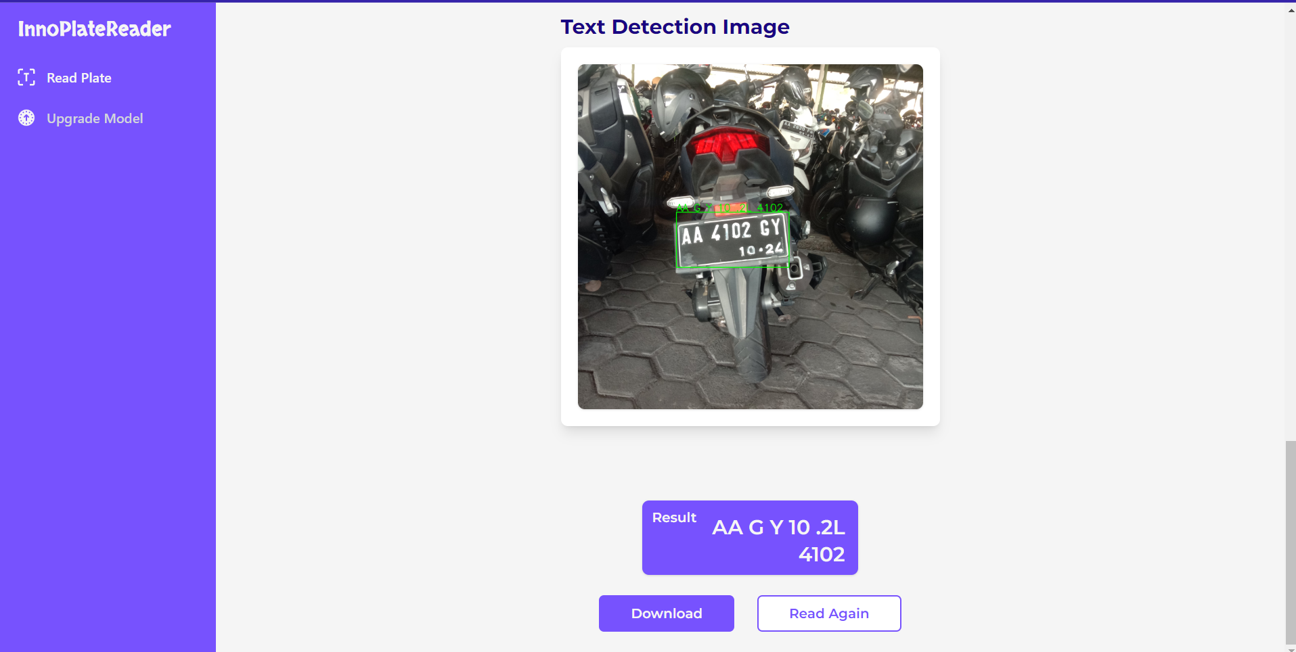

Gambar 1.7 Tampilan Halaman Hasil Predict (Bagian 3)

### Potongan Kode Program Halaman Hasil Predict

<!-- Main Start -->

<section class="p-4 sm:ml-64">

<div class="p-4 ">

<!-- Header -->

<h2 class="text-3xl md:text-4xl font-montserrat font-bold text-accent mt-2 ">Result</h2>

<!-- Images -->

<div class="w-full mx-auto py-10 flex flex-col justify-between sm:border-slate-500 md:border-blue-500 lg:border-rose-500">

<!-- Original Image -->

<div class="mx-auto my-4 md:my-6 lg:my-8">

<h3 class="text-xl md:text-2xl font-montserrat font-bold text-accent my-2">Original Image</h3>

<div class="max-w-md p-4 lg:p-5 mx-auto bg-white rounded-lg shadow-lg">

<!-- <img class="transition-all duration-300 rounded-lg shadow hover:shadow-lg md:hover:shadow-xl hover:shadow-gray-300 ease-in-out md:hover:scale-125" src="{{ url_for('static',filename='images/predict/TD_K1_AA2503XT.JPG') }}" alt="Original Image"> -->

<img class="transition-all duration-300 rounded-lg shadow hover:shadow-lg md:hover:shadow-xl hover:shadow-gray-300 ease-in-out md:hover:scale-125" src="{{ filepath }}" alt="Original Image">

</div>

</div>

<!-- Object Detection Image -->

<div class="mx-auto my-4 md:my-6 lg:my-8">

<h3 class="text-xl md:text-2xl font-montserrat font-bold text-accent my-2">Object Detection Image</h3>

<div class="max-w-md p-4 lg:p-5 mx-auto bg-white rounded-lg shadow-lg">

<img class="transition-all duration-300 rounded-lg shadow hover:shadow-lg md:hover:shadow-xl hover:shadow-gray-300 ease-in-out md:hover:scale-125" src="{{ pathOB }}" alt="Object Detection Image">

</div>

</div>

<!-- Crop Object -->

<div class="mx-auto my-4 md:my-6 lg:my-8">

<h3 class="text-xl md:text-2xl font-montserrat font-bold text-accent my-2">Crop Object</h3>

<div class="max-w-md p-4 lg:p-5 mx-auto bg-white rounded-lg shadow-lg">

<img class="transition-all duration-300 rounded-lg shadow hover:shadow-lg md:hover:shadow-xl hover:shadow-gray-300 ease-in-out md:hover:scale-125" src="{{ pathCrop }}" alt="Crop Object Image">

</div>

</div>

<!-- Text Detection Image -->

<div class="mx-auto my-4 md:my-6 lg:my-8">

<h3 class="text-xl md:text-2xl font-montserrat font-bold text-accent my-2">Text Detection Image</h3>

<div class="max-w-md p-4 lg:p-5 mx-auto bg-white rounded-lg shadow-lg">

<img class="transition-all duration-300 rounded-lg shadow hover:shadow-lg md:hover:shadow-xl hover:shadow-gray-300 ease-in-out md:hover:scale-125" src="{{ pathTD }}" alt="Text Detection Image">

</div>

</div>

</div>

<!-- Result Plate -->

<div class="max-w-sm mx-auto">

<!-- Result -->

<div class="w-2/3 flex flex-row justify-between lg:mt-4 mx-auto p-4 bg-primary rounded-lg shadow hover:shadow-lg md:hover:shadow-xl hover:shadow-gray-300 hover:border-primary transition duration-300 ease-in-out md:hover:scale-125 text-text hover:text-white font-montserrat font-semibold">

<h3 class="text-base -mt-2 -ml-1">Result</h3>

<p class="text-right text-xl lg:text-2xl -mb-2">{{ result_text_plate }}</p>

<!-- <p class="text-right text-xl lg:text-2xl -mb-2">AA2503XT</p> -->

</div>

<!-- More -->

<div class="w-full mx-auto flex flex-col md:flex-row mt-2 md:mt-0 justify-center md:justify-around">

<a href="/download-result" class="w-fit mx-auto text-base text-center font-semibold rounded-md font-montserrat px-9 py-2 mt-4 md:mt-6 duration-300 text-text hover:text-white bg-primary border-primary border-2 focus:ring-4 focus:outline-none focus:ring-primary">

Download

</a>

<a href="/read-again" class="w-fit mx-auto text-base text-center font-semibold rounded-md font-montserrat px-9 py-2 mt-4 md:mt-6 duration-300 text-primary hover:text-white bg-white hover:bg-primary border-primary border-2 focus:ring-4 focus:outline-none focus:ring-primary">

Read Again

</a>

</div>

</div>

</div>

</section>

<!-- Main End -->

# Manual Penggunaan Sistem

## Step by step Proses Training

Langkah-langkah untuk melakukan pelatihan pada sistem yang dibuat adalah sebagai berikut.

Buka sistem hingga halaman beranda muncul.

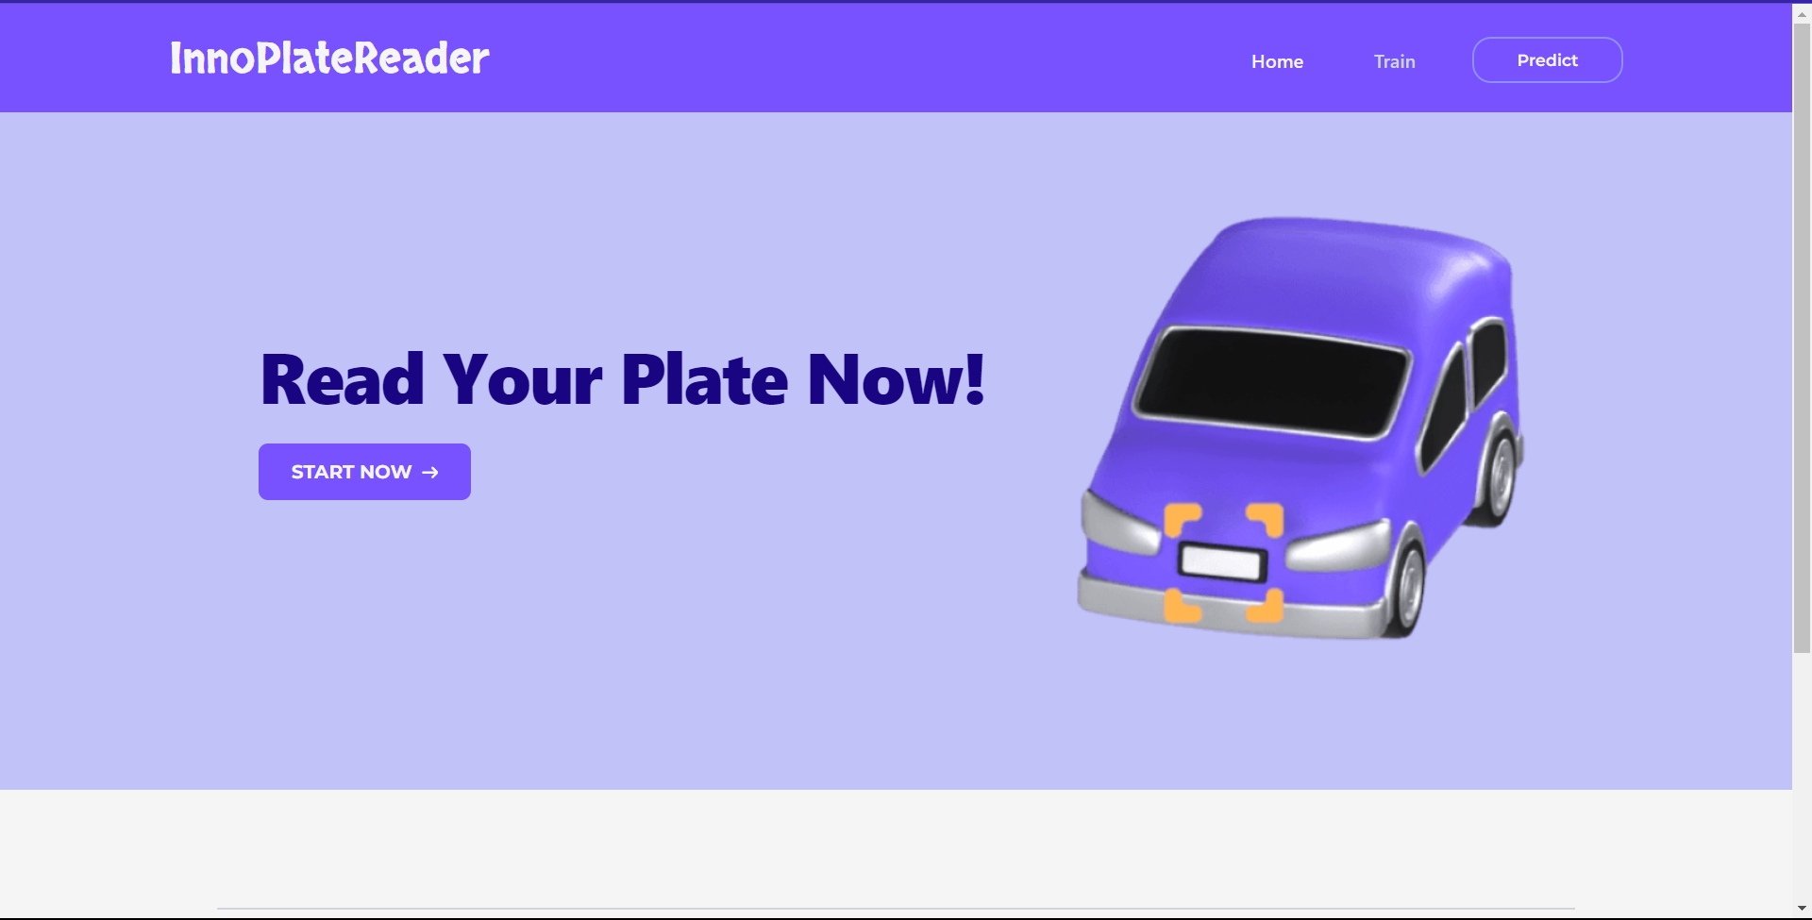

Pilih menu “Train” pada bagian atas (kotak merah nomor 1).



Tunggu hingga halaman pelatihan muncul.

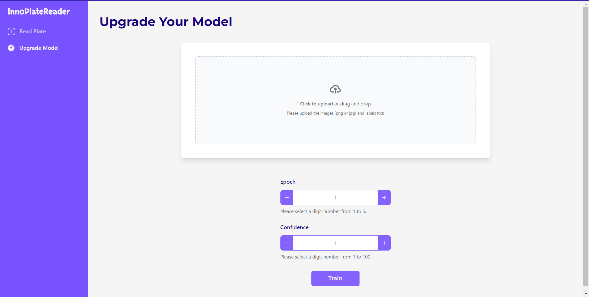

Inputkan data citra dan label, serta seluruh nilai hyperparameter yang diminta yakni epoch dan confidence.



Klik tombol “Train” (kotak merah).



Proses pelatihan selesai ditandai dengan tampilnya grafik hasil pelatihan, yakni grafik confusion matrix (kotak merah).

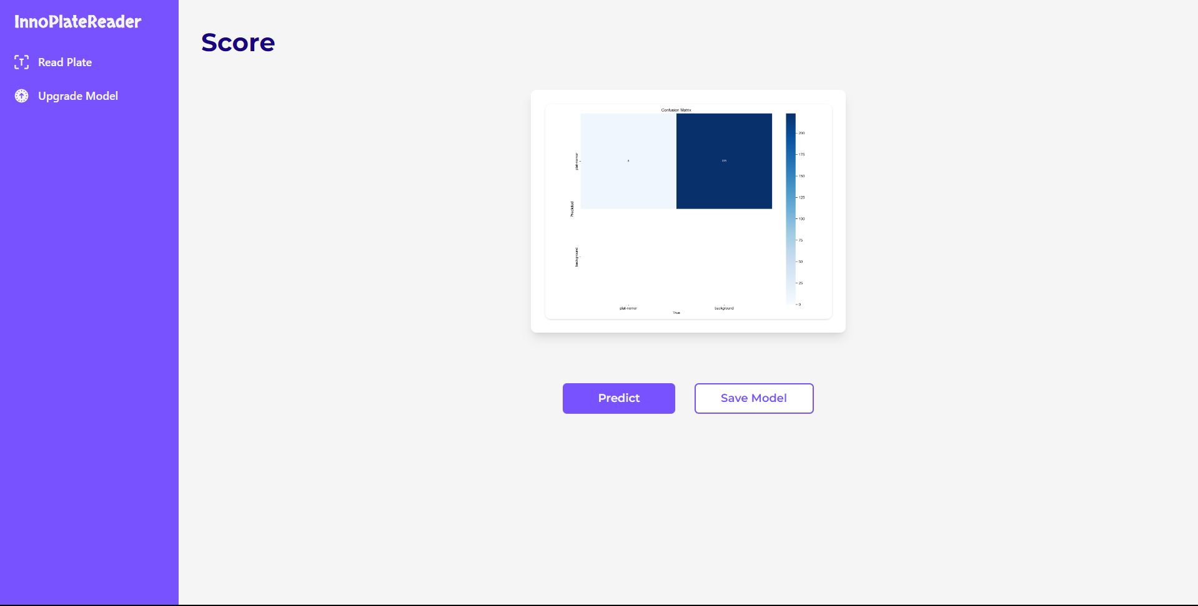

## Step by step Proses Predict

Langkah-langkah untuk melakukan pengujian atau prediksi pada sistem yang dibuat adalah sebagai berikut.

Buka sistem hingga halaman beranda muncul.



Pilih menu “Predict” pada bagian atas atau klik tombol “Start Now”.



Tunggu hingga halaman predict muncul.

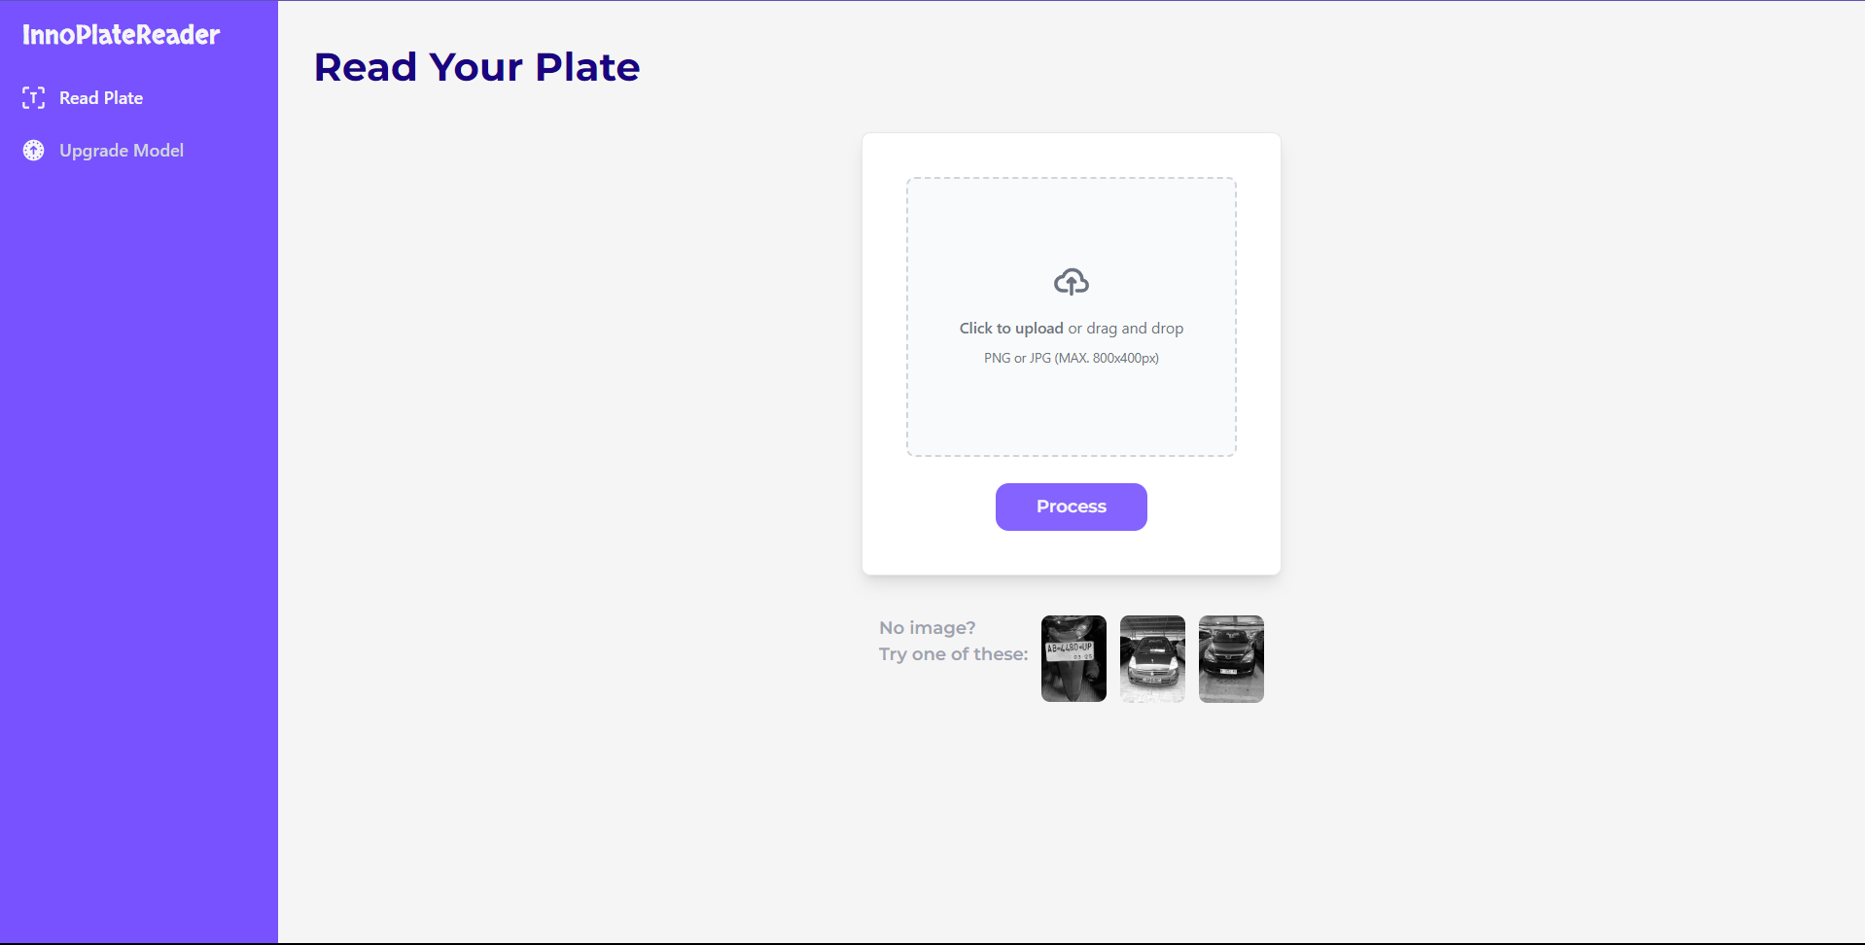

Lakukan upload citra yang akan diuji, dengan mengeklik area dropzone atau dengan melakukan drag and drop file citra uji.



Jika citra uji sudah dipilih, maka selanjutnya tekan tombol “Process” untuk memulai proses prediksi.



Setelah proses pengujian selesai, maka sistem akan menampilkan halaman hasil predict.

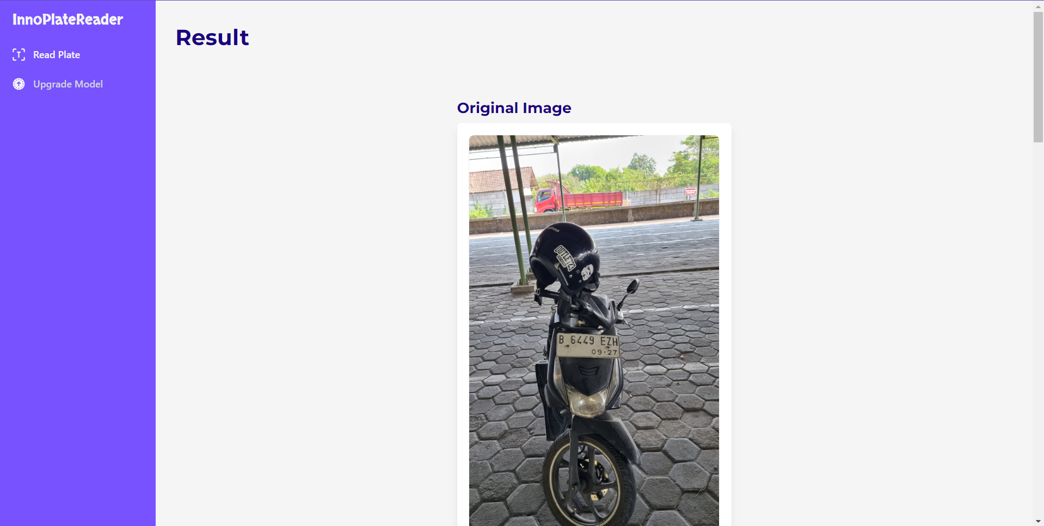

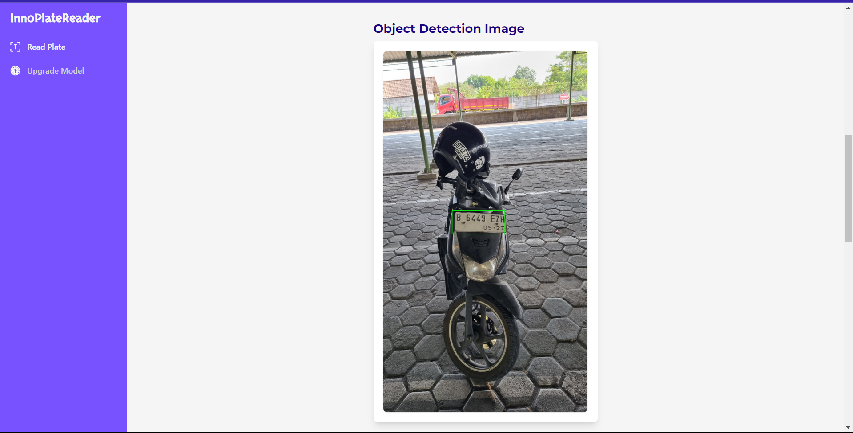

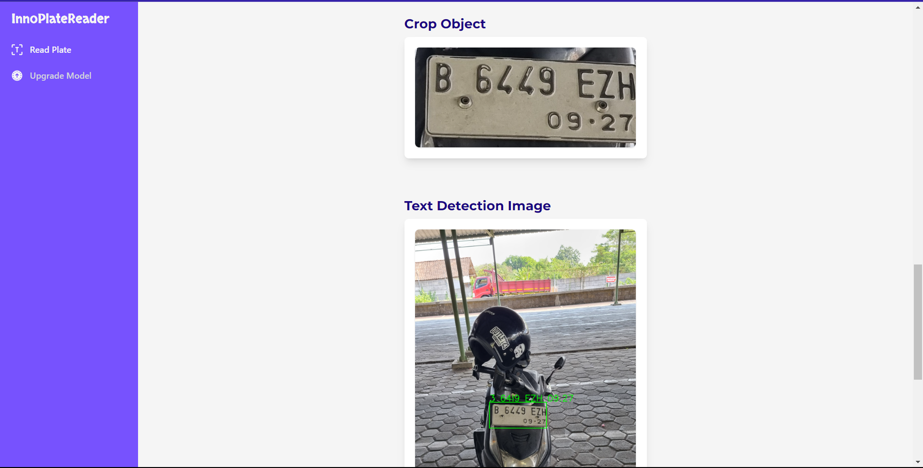

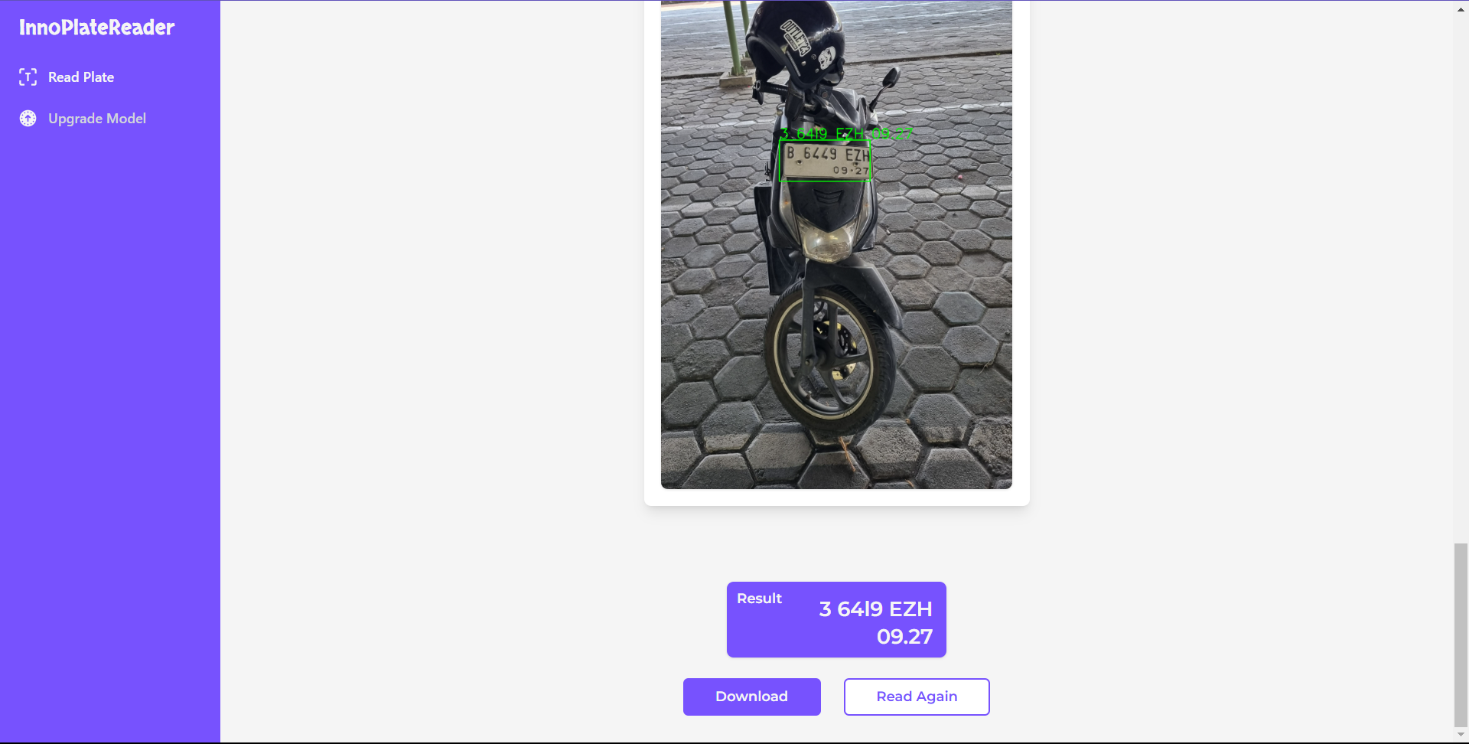

Pengguna dapat mengembalikan halaman pengujian ini kembali bersih seperti pada langkah ke-1 dengan meng-klik tombol “Read Again”. Selain itu, pengguna dapat men-download hasil dari prediksi dengan meng-klik tombol “Download”.

